

2017-2018 Academic Year

Fall Semester

Final Exam Paper

**Course Name：CS203 Data Structure and Algorithm Analysis**

**Department: Department of Computer Science and Engineering**

**Exam Duration：2 hours**

**Note 1:** Write all your solutions in the question paper directly. You can ask additional answer paper if necessary

**Note 2:** If a question asks you to design an algorithm, full marks will be given if your algorithm runs with optimal time complexity

**Note 3:** If a question asks you to design an algorithm, you only need to describe your ideas as concise as possible.

|  |  |  |  |  |  |  |  |  |  |
| --- | --- | --- | --- | --- | --- | --- | --- | --- | --- |
| **Question No.** | Part I | Part II | P1 | P2 | P3 | P4 | P5 | P6 |  |
| **Score** |  |  |  |  |  |  |  |  |  |

# This exam paper contains _26_questions and the score is _100_ in total. (Please hand in your exam paper, answer sheet, and your scrap paper to the proctor when the exam ends.)

1. **Part I - Multiple Choice. [20 marks, 2 marks for each problem]**

1. Insert a new element into a sorted single linked list, which is the correct time complexity if we still want to keep the list as sorted after insertion? ( )

A.O(1) B. O(n) C.O (n2) D. (nlogn)

2. What is the postfix expression of a*(b+c)-d? ( )

A. abcd*+- B. abc+*d- C. abc*+d- D. -+*abcd

3. Which of the following should be implemented on the basis of the queue structure? ( )

A. Bracket matching B. DFS C. Recursion D. BFS

4. Given a binary tree with pre-order sequence of 1234567, which of the following can be its in-order sequence? ( )

A. 3124567 B. 1234567 C. 4135627 D. 1463572

5. There are 130 nodes in a complete binary tree, what is its height? ( )

A.4 B.5 C. 6 D. 7

6. Given a binary tree, if its pre-order is A,B,C and post-order is C,B,A, how many possible structures of it can there be? ( )

A.1 B.2 C.3 D.4

7.Suppose we use S represents the operation of pushing into the stack and X of popping of the stack,

Suppose that the sequence of pushing into stack is 1234, which is the correct operation sequence to get a pop sequence of 1342. ( ).

A. SXSXSSXX B. SSSXXSXX

C. SXSSXXSX D. SXSSXSXX

8. How many nodes in a full binary tree with height h? ( )

A. 2h-1 B.2h-1 C.log2h D.2h

9. Given a ring with n nodes, how many spanning trees can be generated from it? ( )

A. n2  B. n C.n-1 D. 1

10. Given an undirected graph with 6 nodes, how many edges should there be to guarantee its connectivity? ( )

A. 8 B. 9 C. 10 D. 11

1. **Blank Filling Questions. [20 marks]**
2. Given a sequence of pushing into a stack is 4321, the sequence of popping of the stack will be

**1234** [2 marks]

1. Suppose the binary search tree is given as follows, we want to find the element 25, the sequence of the searching process will be

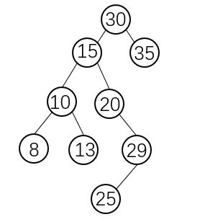

30, 15, 20, 29, 25 [2 marks]

1. Suppose that we use an array to simulate a ring queue with size **n**, **rear** and **front** are the index value of the rear of queue and the front of queue, respectively. When **rear == front**, the queue is empty. In which circumstance the queue is full?

**(rear+1)%n = front** [2 marks]

1. When using array to store complete binary tree, suppose the index of a node is i (the first element’s index is 0), its left node’s index will be

2i+1 [2 marks]

1. Given a complete binary tree, suppose its 6th level (root is the first level) has 8 leaf nodes, the binary tree has nodes at most.

**111[ 4 marks]**

1. The time complexity of inserting a new element into a heap with n elements is

**O(logn)**[2 marks]

1. We want to use binary code (0 or 1) to encryption a string, i.e., use an unique binary code to represent each distinct character in string. For example, suppose **b, o, c** can be represented as **“0”,** **“10”,** **“11”,** respectively. The encryption sequence of **“boot”** will be “**0101011**”, the maximum length of encrypting one character in “boot” is **2** and the length of binary sequence is **7**.) Design a method to encrypt “**cscccddoosdossdassdkskds**” using binary code and make sure that the length of encrypted binary sequence is **minimum**. The maximum bit length of the characters in “**cscccddoosdossdassdkskds**” is **4**. The total binary sequence length of the above string is **57.** [4 marks]
2. We plan to hold a party at SUSTech, so some students are rehearsing for one show. We want to line up these students by the ascending order of their heights. However, there is no height-measuring instrument, we can only get the height result through pairwise comparison. For example, A<B, C<D means B is higher than A, and A should be placed in front of B. If there are 8 students, their height relationships are: A<B, A<C, B<C, B<E, B<D, C<D, E<D, E<F, E<G, D<G, F<G, F<H, G<H. Please write down all the queuing sequences which satisfy the above requirement: . [4 marks]

**ABECDFGH**

**ABEFCDGH**

**ABCEDFGH**

**ABCEFDGH**

**ABECFDGH**

1. Given an undirected graph (no self-loop) with n vertices and e edges, how many zero elements in its adjacent matrix? __________

n2 - 2e

1. Looking the following code, what is its time complexity?

.

void fun( int n) {

int i = 1;

while(i <= n)

i = i*2;

}

O(log2N) [4 marks]

**[Problem I, 8 marks] Quick sort is an interesting algorithm. Given the following code**

**you should complete the code and answer the questions.**

1. **Complete the quick_sort function**

**void quick_sort(int s[], int l, int r)**

**{**

**if (l < r)**

**{**

**//Swap(s[l], s[(l + r) / 2]);**

**int i = l, j = r, x = s[l];**

**while (i < j)**

**{**

**while(i < j && s[j] >= x)**

**j--;**

**if(i < j)**

**s[i++] = s[j];[4 marks]**

**while(i < j && s[i] < x)**

**i++;**

**if(i < j)**

**s[j--] = s[i];**

**}**

**s[i] = x;**

**quick_sort(s, l, i - 1);**

**quick_sort(s, i + 1, r);**

**}**

**}**

1. What’s the time complexity of this function? O(logn)[2 marks]
2. What is the outcome of the first call of recursive process when using this quick sort function to solve the sequence of 46, 79, 56, 38, 40, 84.

40, 38, 46, 56, 79, 84[2 marks]

**[Problem II, 8 marks]**

1. Please use dynamic array to create a min root heap of the given sequence 8,5,2,6,7,3,11,9 (plot the tree of heap and dynamic array).

|  |  |  |  |  |  |  |  |
| --- | --- | --- | --- | --- | --- | --- | --- |
| 8 | 7 | 11 | 6 | 5 | 3 | 2 | 9 |
| 8 | 7 | 2 | 6 | 5 | 3 | 11 | 9 |
| 8 | 5 | 2 | 6 | 7 | 3 | 11 | 9 |
| 2 | 5 | 8 | 6 | 7 | 3 | 11 | 9 |
| 2 | 5 | 3 | 6 | 7 | 8 | 11 | 9 |

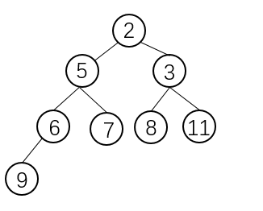

1. Plot the adjusting process of inserting a new element 4. ( plot the tree of heap and dynamic array)

|  |  |  |  |  |  |  |  |  |
| --- | --- | --- | --- | --- | --- | --- | --- | --- |
| 2 | 5 | 3 | 6 | 7 | 8 | 11 | 9 | 4 |
| 2 | 5 | 3 | 4 | 7 | 8 | 11 | 9 | 6 |
| 2 | 4 | 3 | 5 | 7 | 8 | 11 | 9 | 6 |

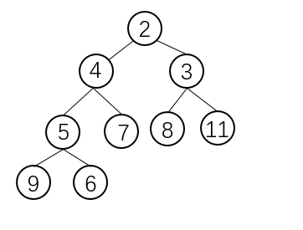

1. After inserting element 4 into the heap, you should get a new min root heap, please plot the process of deleting the smallest element of the heap. (plot the tree of heap and dynamic array)

|  |  |  |  |  |  |  |  |  |
| --- | --- | --- | --- | --- | --- | --- | --- | --- |
| 2 | 4 | 3 | 5 | 7 | 8 | 11 | 9 | 6 |
| 6 | 4 | 3 | 5 | 7 | 8 | 11 | 9 |  |
| 3 | 4 | 6 | 5 | 7 | 8 | 11 | 9 |  |

